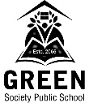**GREEN SOCIETY PUBLIC SCHOOL**

**RATNANAGAR-7, CHITWAN**

**THIRD TERMINAL EXAMINATION-2080**